HW #5 Microservice using Lambda and API Gateway

Shashank Reddy Gopireddy

David Tang

Haixiang Yu

Venkata Kalyan Ponduri

**To create an API**

1. Sign in to the AWS Management Console and open the AWS Lambda console.
2. Choose **Create Lambda function**.
3. Choose **Blueprint**.
4. Enter **microservice** in the search bar. Choose the **microservice-http-endpoint** blueprint and then choose **Configure**.
5. Configure the following settings.
   * **Name** – **lambda-microservice**.
   * **Role** – **Create a new role from AWS policy templates**
   * **Role name** – **lambda-apigateway-role**.
   * **Policy templates** – **Simple microservice permissions**.
   * **API** – **Create a new API**.
   * **Security** – **Open**.

Choose **Create function**.

**To create a DynamoDB table**

1. Open the [DynamoDB console](https://console.aws.amazon.com/dynamodb).
2. Choose **Create table**.
3. Create a table with the following settings.
   * **Table name** – **Lab-5**
   * **Primary key** – **nothing** (string)
4. Choose **Create**.

**To enable streams**

1. Open the [DynamoDB console](https://console.aws.amazon.com/dynamodb).
2. Choose **Tables**.
3. Choose the **lambda-dynamodb-stream** table.
4. Under **Overview**, choose **Manage stream**.
5. Choose **Enable**.

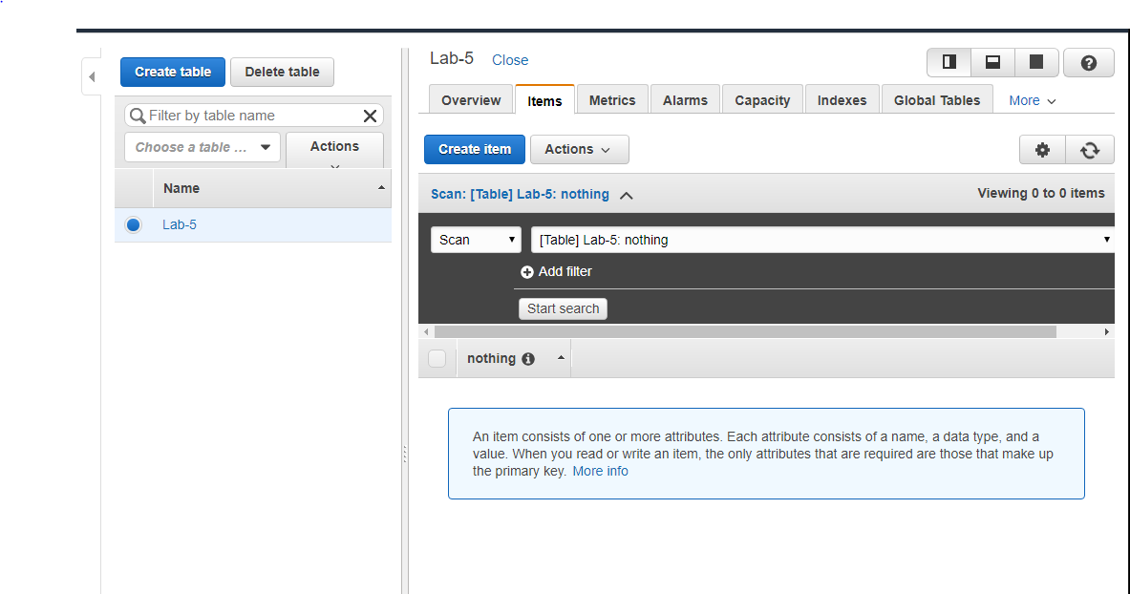

Excution results for GET

“200” means succeeded

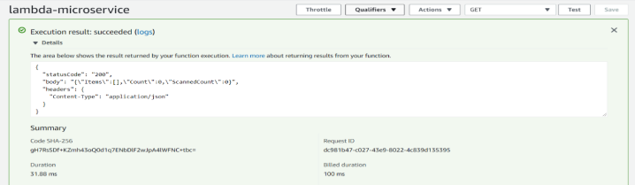

Excultion results for POST

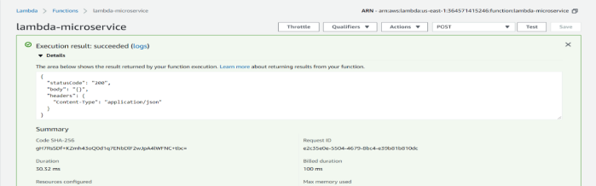

“200” means succeeded and no error

And an item has been created in table.

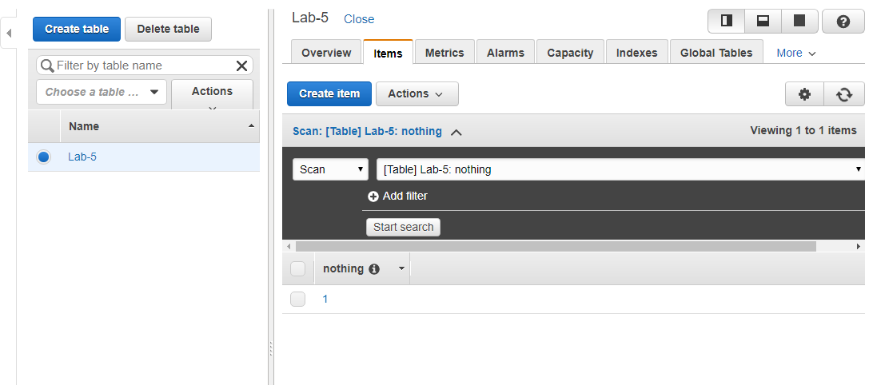

Acting GET again to verify

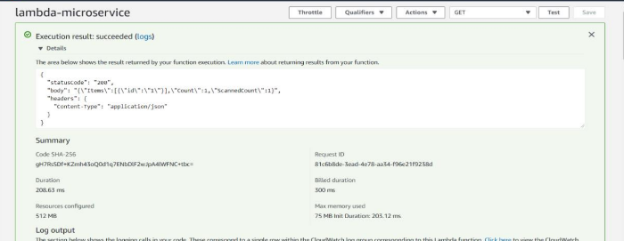

Acting PUT to change the item number to 2

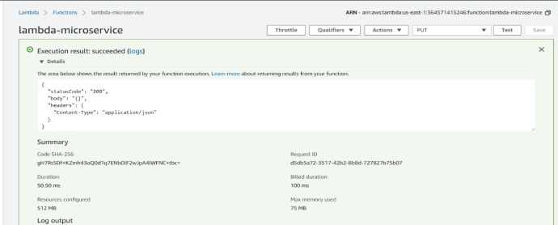

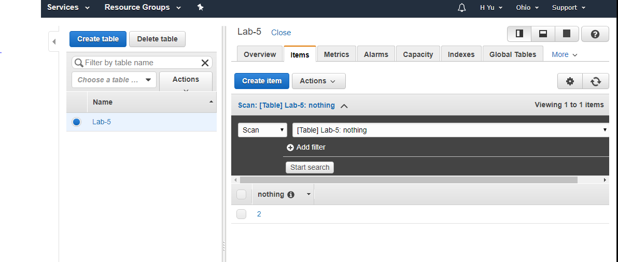

Acting DELETE to delete item 2

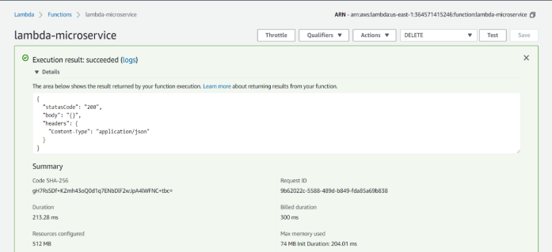

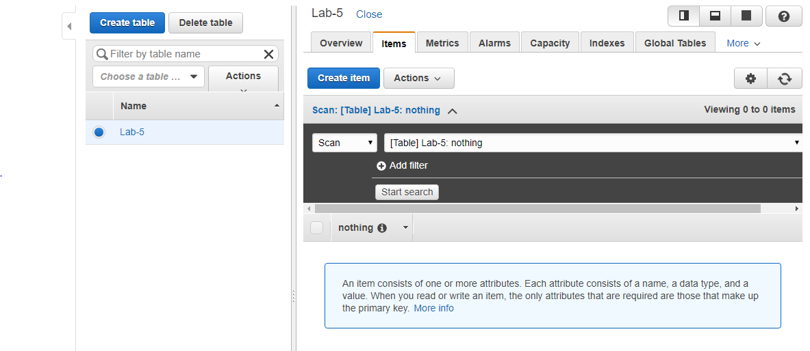

Github:

<https://github.com/Kwn1247/CMPE-207/tree/master/Assignments/Lab%205>